2024 Wausau Festival of Arts
Proposal/Contract Form

Name of Organization: _______________________________________________

Contact Person : __________________________________________

Email Address: _____________________________________________________

Contact’s Telephone #:_____________________

Description of food and beverage items you plan to sell. Prices not required. Minimum beverage pricing will be determined by participating food vendors at our August meeting. ___________________________________________________________________
___________________________________________________________________
___________________________________________________________________
___________________________________________________________________
____________________________________________________________________________________________________________________________________________________________________________________________________________________________________________________________________________
We require a site that is 10 feet deep (max allowed) by _________ feet in length.

Description and exact measurements of structure and any free standing equipment (i.e. trailer, tent, grills, tables, soda coolers, etc.) _______________________________________________________________________________________________________________________________________________________________________________________________________________________________________________________________________________________________________________________________________________
______________________________________________________________________________________________________________________________________
The plug configurations displayed below are the only ones supplied by the City of Wausau. Please indicate which one you will be using.
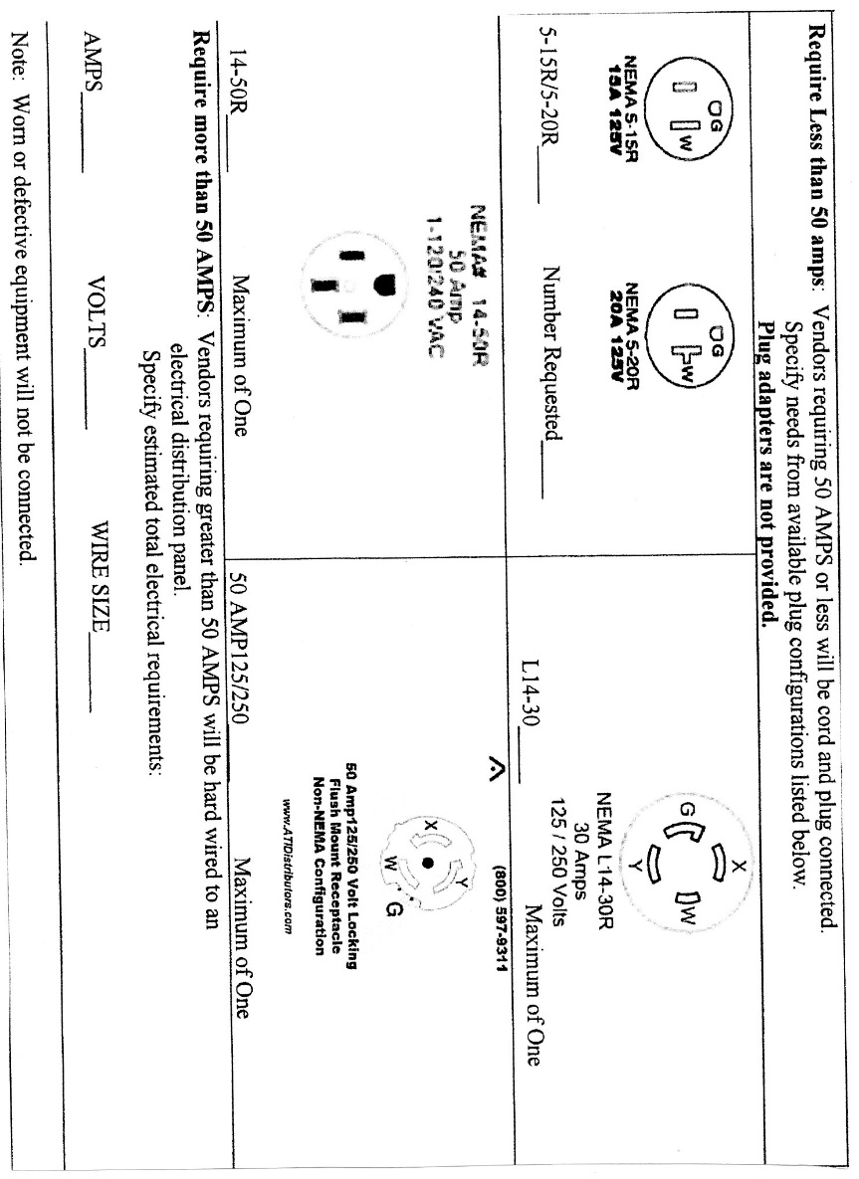

Electrical Needs: The Health Department requires that you have hot water available at all times. Please adjust your appliance needs accordingly. Please indicate the number of each appliance that your organization will be using, and the corresponding voltage and amperage.

Number Volts Amps
____ Soda Cooler ______ _______
____ Water Heater ______ _______
____Nesco Roaster ______ _______
____Coffee Maker / ______ _______
16 cup + up
____Coffee Maker/ ______ _______
16 cup or less
____Broiler ______ _______
____Deep Fat Fryer ______ _______
____Fry Pan ______ _______
____Griddle ______ _______
____Hot Plate ______ _______
____Water heater ______ _______
____Refrigerator/
____ Freezer ______ _______
____Microwave ______ _______
____Dishwasher ______ _______
____Small Range ______ _______
____Chafing Dish ______ _______
____Lighting ______ _______
Other Appliances:
____ _____________ _______ _________
____ ___________ ______ ________
____ ___________ ______ ________

Your $75.00 registration fee must accompany this proposal. Mail to Nancy Dolenshek, 1012 Everest Blvd, Wausau, WI 54403. Please make checks payable to the Wausau Festival of Arts, Inc. It is understood that your $75.00 registration fee is non-refundable unless your application is denied by the Festival of Arts or the 2024 Festival should be cancelled.

Proposal submitted by: ______________________________ Date: ___________

